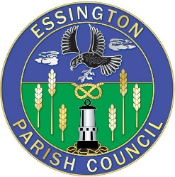Essington Parish Council 11th July 2022

Management Meeting to be held 11th July 2022 @ 6.30 pm in the Council Chamber
Public and Tennant’s Participation 15 Mins
1. Apologies
2. Declarations of Interest
3. Approval of the last meeting minutes 30th May 2022
4. Matters Arising
5. Centres
5.1 ECC
a) Drains
b) Community-users Key Saf
C) One way system ECC

5.2 Medical Centre- Update
5.3 Long Lane- Wyrley Juniors/ Teddy bears
5.4 Broad Lane
5.5 Westcroft
5.6 Swan Park
5.7 Pools
6. Highways - Update
7. Date of the Next Meeting
8. Closure

Signed by Louise Tipler 5th July 2022

